EXPERIMENT 4
AIM:To write and implement a C program to generate Three
Address Code (TAC) for a given arithmetic expression.
ALGORITHM:
•Start the program.
•Read the input expression.
•Separate the target variable from the RHS expression. •Create stacks for operators and operands.
•Scan the expression from left to right.
•Push operands into the operand stack.
•Push operators into the operator stack according to their precedence.
•Process operators when required.
•Generate temporary variables t1, t2, etc.
•Display the generated Three Address Code.
•Assign the final temporary result to the target variable. •Stop.

PSEUDO CODE:
START
Read expression
Separate target variable
Initialize operator stack
Initialize operand stack
Set temp = 1
FOR each character in expression
IF character is operand
Push operand
ELSE IF character is '('
Push '('
ELSE IF character is ')'
Process operators until '('

ELSE IF character is operator
Process operators with higher/equal precedence
Push current operator
END FOR
Process remaining operators
Assign final result to target variable
Display TAC
STOP

PROGRAM:
#include <stdio.h> #include <stdlib.h> #include <ctype.h> #include <string.h>
#define MAX 100
char opStack[MAX]; int opTop = -1;
char *valStack[MAX]; int valTop = -1;
int tempCount = 1;
void pushOp(char ch) { opStack[++opTop] = ch; }
char popOp() { return opStack[opTop--]; }
char peekOp() { return opStack[opTop]; }
char *copyString(char *str) { char *p = (char *)malloc(strlen(str) + 1); strcpy(p, str); return p; }
void pushVal(char *val) { valStack[++valTop] = copyString(val); } char *popVal() { return valStack[valTop--]; }
int precedence(char op) { if (op == '+' || op == '-') return 1;
if (op == '*' || op == '/') return 2;
return 0;
}

void processOperator() { char op; char *left, *right; char temp[20];
op = popOp();
right = popVal();
left = popVal();
sprintf(temp, "t%d", tempCount++);
printf("%s = %s %c %s\n",
temp, left, op, right);
pushVal(temp);
free(left);
free(right);
}
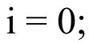void generateTAC(char expr[]) { int i = 0; int k;
char target[MAX] = "";
char operand[MAX];
while (expr[i] != '=' && expr[i] != '\0') {
if (!isspace(expr[i]))
{
target[strlen(target)] = expr[i]; }
i++;
}

target[strlen(target)] = '\0';
if (expr[i] == '=')
i++;
printf("\nThree Address Code (TAC):\n"); printf("-------------------------\n");
while (expr[i] != '\0')
{
if (isspace(expr[i]))
{
i++;
continue;
}
if (isalnum(expr[i]))
{
k = 0;
while (isalnum(expr[i]))
{
operand[k++] = expr[i++];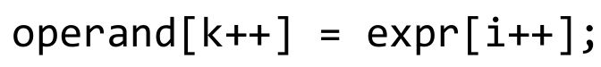 }
operand[k] = '\0';
pushVal(operand);
}
else if (expr[i] == '(')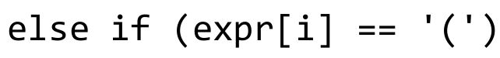
{

pushOp(expr[i]);
i++;
}
else if (expr[i] == ')')
{
while (opTop >= 0 && peekOp() != '(') processOperator();
popOp();
i++;
}
else if (expr[i] == '+' ||
expr[i] == '-' ||
expr[i] == '*' ||
expr[i] == '/')
{
while (opTop >= 0 &&
precedence(peekOp()) >= precedence(expr[i]))
{
processOperator();
}
pushOp(expr[i]);
i++;
}
else
{

i++;
}
}
while (opTop >= 0)
processOperator();
if (target[0] != '\0')
{
char *result = popVal();
printf("%s = %s\n", target, result);
free(result);
}
}
int main() { char expr[MAX];
printf("Enter expression: "); fgets(expr, MAX, stdin);
generateTAC(expr);
return 0;
}
INPUT:

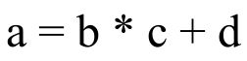
OUT PUT:
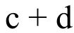Enter expression: a = b * c + d
Three Address Code (TAC):
-------------------------
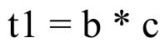
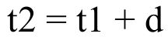
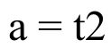
RESULT:
Thus, the C program to generate Three Address Code for an arithmetic expression was successfully executed

